Important
Install the EPROG5 program only from a Windows user 'Administrator' account. Install the USB light pen driver and pen hardware, as detailed in annex 1.

Run the Capsule programming software from the desk top icon.

Stage 1, set the Beacon programming information;

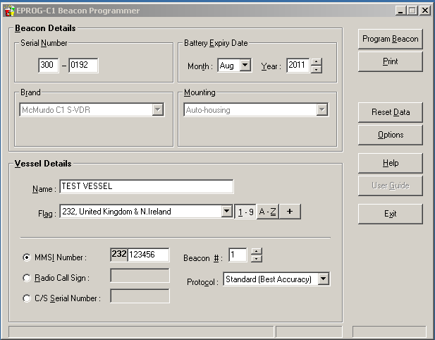

1/ Serial number must start 300

2/ Serial number second part must be taken from the label on the top cone of the Capsule, in this example serial number 00192

3/ Enter vessel name

4/ Select appropriate country code according to vessels MMSI number / flag

5/ Enter remaining 6 numbers of vessels MMSI

6/ Set ID number of Beacon, (2 if the vessel already has 1 EPIRB)

7/ Leave protocol set as 'Standard' unless otherwise requested by vessel flag state authority.

8/ Enter the battery expiry date indicated on the lower capsule body

Stage 2, Use the options menu to select the COM port allocated by the PC to the USB programming pen.

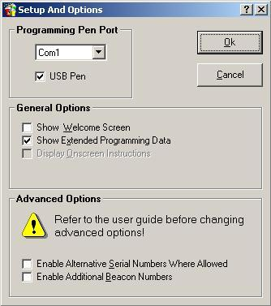

Note. Advanced options should be left un-ticked

Stage 3, Select ‘Program Beacon’ to verify the data is correct.

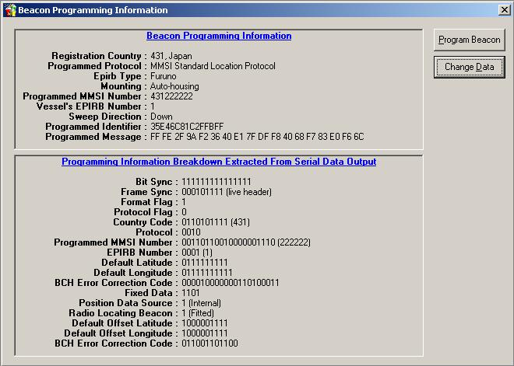

Review the information provided, if correct select ‘Program Beacon’ and follow the information on screen. Or ‘Change data’ to return to the previous menu.

Stage 4, follow the on screen programming instructions (below).

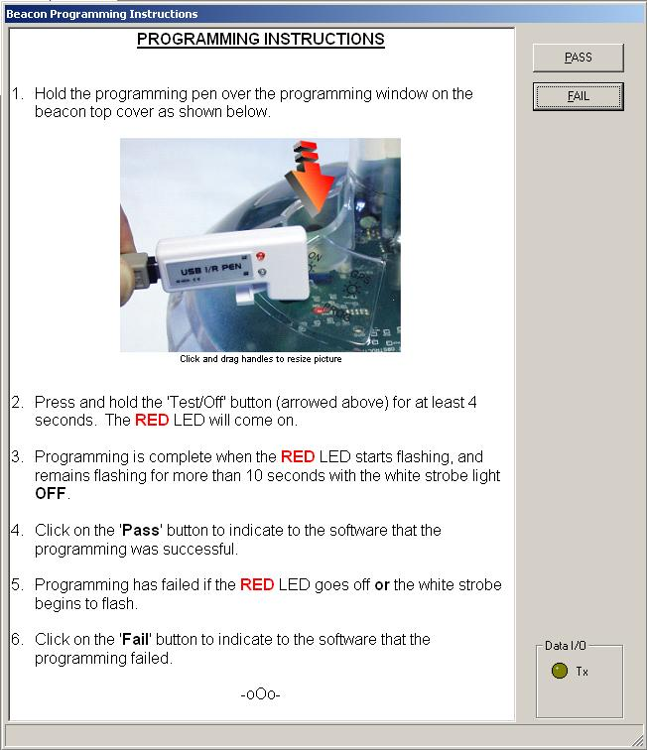

Note. Typically, the time period between stage 2 and 3 is very short, once the RED LED starts to flash the programming is successful.

Stage 5, Select label and document print options

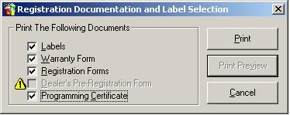

Print labels and documents directly to paper or were supported by the PC to a PDF file for later printing. Printing by laser printer is recommended to minimize any later water damage.

The capsule programming identity label should be prepared and applied under the clear self adhesive ‘Dome clear overstick label’ part 36-134 (supplyed with Capsule).

Refer to VR-3030 operation manual for further information.

Anex1.

Instructions for installing the USB Beacon Programming Pen in Windows XP

The USB programming pen drivers must be installed by an administrator, or a user with administrator privileges.

The installation process is in two steps, the Windows "Found New Hardware" wizard will run twice, once for the interface drivers and once for the programming pen itself.

Stage 1, To install the programming pen, connect the USB programming pen to the PC - the Windows "Found New Hardware" wizard should start.

1: When the wizard asks "What do you want the wizard to do ?", select the advanced option labelled "Install from a list or specific location (Advanced)", and then click "Next>".

2: Select the "Search for the best driver in these locations." option.

3: Un-check the "Search removeable media (floppy, CD-ROM...)" check box so that the option is not selected.

4: Check the "Include this location in the search:" check box so that the option is selected.

5: Click "Browse" to find the location of the CD-ROM drive that has this CD in it and then click "OK".

6: Click "Next>". The wizard will begin to copy the drivers.

7: If a message about Windows Logo testing appears, click "Continue Anyway" to finish loading the drivers.

8: Once the drivers are loaded click on "Finish".

Stage 2, The Windows "Found New Hardware" wizard will automatically start.

1: When the wizard asks "What do you want the wizard to do ?", select the advanced option labelled "Install from a list or specific location (Advanced)", and then click "Next>".

2: Select the "Search for the best driver in these locations." option.

3: Un-check the "Search removeable media (floppy, CD-ROM...)" check box so that the option is not selected.

4: Check the "Include this location in the search:" check box so that the option is selected.

5: Click "Browse" to find the location of the CD-ROM drive that has this CD in it and then click "OK".

6: Click "Next>". The wizard will begin to copy the drivers.

7: If a message about Windows Logo testing appears, click "Continue Anyway" to finish loading the drivers.

8: Once the drivers are loaded click on "Finish".

THE USB PROGRAMMING PEN IS NOW INSTALLED AND IS READY FOR USE.

Windows will automatically assign the next available COM: port number to the programming pen. In most PCs this is either COM3 or COM4, however the exact number will depend on how many COM: devices you have installed already.

